Project Planning Report

On

“EEG data Analysis & Visualization”

Submitted by

Suyog Chavan

Ritesh Shende

Sanket Pophale

Rushikesh Shinde

Under the guidance of

Prof. H. Ohal

*In particular fulfilment of*

Diploma in Computer Engineering

[2021-22]

At



DEPARTMENT OF COMPUTER ENGINEERING

MIT POLYTECHNIC

PUNE-411038

Affiliated to



MSBTE



MAHARASHTRA STATE BOARD OF TECHNICAL EDUCATION

CERTIFICATE

This is to certify that Mr. Suyog Santosh Chavan from MIT Polytechnic, Pune having enrollment number 1901480181 has completed Project Planning Report having title EEG Data Analysis & Visualization in a group constiting of 4 candidates under the guidance of Prof. H.Ohal

Name & Signature of Guide Name & Signature of HOD



MAHARASHTRA STATE BOARD OF TECHNICAL EDUCATION

CERTIFICATE

This is to certify that Mr. Ritesh Shende from MIT Polytechnic, Pune having enrollment number 1901480182 has completed Project Planning Report having title EEG Data Analysis & Visualization in a group consisting of 4 candidates under the guidance of Prof. H.Ohal

Name & Signature of Guide Name & Signature of HOD



MAHARASHTRA STATE BOARD OF TECHNICAL EDUCATION

CERTIFICATE

This is to certify that Mr. Rushikesh Shinde from MIT Polytechnic, Pune having enrollment number 1901480183 has completed Project Planning Report having title EEG Data Analysis & Visualization in a group constiting of 4 candidates under the guidance of Prof. H.Ohal

Name & Signature of Guide Name & Signature of HOD



MAHARASHTRA STATE BOARD OF TECHNICAL EDUCATION

CERTIFICATE

This is to certify that Mr. Sanket Pophale from MIT Polytechnic, Pune having enrollment number 1901480185 has completed Project Planning Report having title EEG Data Analysis & Visualization in a group constiting of 4 candidates under the guidance of Prof. H.Ohal

Name & Signature of Guide Name & Signature of HOD

ACKNOWLEDGMENT

It is our privilege to express our sincerest regards to our project guide, Prof. Mrs. H. Ohal for her valuable inputs, able guidance, encouragement, whole-hearted cooperation and constructive criticism throughout the duration of our project.

We deeply express our sincere thanks to our Principal Dr. Prof. R. S. Kale and Head of Computer Engineering Department Prof.J.G.Mante (Khurpade)

We take this opportunity to thank all our lecturers who have directly or indirectly helped our project.

Suyog Chavan

Ritesh Shende

Rushikesh Shinde

Sanket Pophale

Diploma in Computer Engineering

ABSTRACT

An electroencephalogram, or EEG, is used to monitor the electrical activity in the brain through electrodes placed on the scalp. An EEG can determine changes in brain activity that might be useful in diagnosing brain disorders, especially epilepsy or another seizure disorder. An EEG might also be helpful for diagnosing or treating some disorders like Brain tumor, Brain damage from head injury.

An EEG may also be used to determine if someone in a coma has died or to find the right level of anesthesia for someone in a coma. The EEG is a time-varying or nonstationary signal. Frequency and amplitude are two of its significant characteristics, and are valuable clues to different states of brain activity. Detection of these temporal features is important in understanding EEGs. Commonly, spectrograms and AR models are used for EEG analysis. However, their accuracy is limited by their inherent assumption of stationarity and their trade-off between time and frequency resolution. This makes it so difficult and time consuming. In this project we investigate EEG signal processing using existing compound kernel time-frequency distributions (TFDs). That’s the reason why EEG data monitoring and visualization is important. This project is built for making an EEG data structure easier to Analyze and understand.

**TABLE OF CONTENTS**

|  |  |  |
| --- | --- | --- |
|  | CONTENTS | PAGE NO. |
| 1 | **Introduction** | 1 |
|  | 1.1 Motivation |  |
| 1.2 Background |  |
| 1.3 Need of the Project |  |
| 1.4 Introduction of Project |  |
| 2 | **Literature Survey** |  |
| 3 | **Proposed Detailed Methodology** |  |
|  | 3.1 Problem Definition |  |
| 3.2 Proposed Methodology |  |
| 3.3 Resources Required |  |
| 3.4 System Architecture |  |
| 3.6 Action Plan |  |
| 4 | **References** |  |

**Chapter 1. Introduction**

* 1. **Motivation**

An electroencephalogram, or EEG, is used to monitor the electrical activity in the brain through electrodes placed on the scalp.

An EEG can determine changes in brain activity that might be useful in diagnosing brain disorders, especially epilepsy or another seizure disorder. An EEG might also be helpful for diagnosing or treating some disorders like Brain tumor, Brain damage from head injury. That’s the reason why EEG data monitoring and visualization is important. This project is built for making an EEG data structure easier to Analyze and understand.

* 1. **Background**

This project provides a platform where Doctor, Researcher, Students can Analyze as well as Visualize the EEG data in advanced but simpler way. This project will be created in python language with the help of some tools and modules like MNE, jupyter notebook etc. The main aim of this project is to making an EEG data easier to understand and analyses by using some enhanced and advanced 3D graph and diagram plotting technics available in python.

* 1. **Need of the Project**

EEGs are used to diagnose conditions like:

* Brain tumors
* Brain damage from a head injury
* Brain dysfunction from various causes (encephalopathy)
* Inflammation of the brain (encephalitis)
* Seizure disorders including epilepsy
* Sleep disorders
* Stroke

An EEG may also be used to determine if someone in a coma has died or to find the right level of anaesthesia for someone in a coma.

The EEG is a time-varying or nonstationary signal. Frequency and amplitude are two of its significant characteristics, and are valuable clues to different states of brain activity. Detection of these temporal features is important in understanding EEGs. Commonly, spectrograms and AR models are used for EEG analysis. However, their accuracy is limited by their inherent assumption of stationarity and their trade-off between time and frequency resolution. This makes it so difficult and time consuming. In this project we investigate EEG signal processing using existing compound kernel time-frequency distributions (TFDs).

The main aim of this project is to making an EEG data easier to understand and analyse by using some enhanced and interactive 3D graph and diagram plotting technics available in python/jupyter.

* 1. **Introduction of the Project**

Electroencephalography (EEG) measure the weak electromagnetic signals generated by neuronal activity in the brain. Using these signals to characterize and locate neural activation in the brain is a challenge that requires expertise in physics, signal processing, statistics, and numerical methods. As part of the MNE software suite, MNE-Python is an open-source software package that addresses this challenge by providing state-of-the-art algorithms implemented in Python that cover multiple methods of data pre-processing, source localization, statistical analysis, and estimation of functional connectivity between distributed brain regions. All algorithms and utility functions are implemented in a consistent manner with well-documented interfaces, enabling users to create EEG data analysis pipelines by writing Python scripts. Moreover, MNE-Python is tightly integrated with the core Python libraries for scientific computation (NumPy, SciPy) and visualization (matplotlib and Mayavi), as well as the greater neuroimaging ecosystem in Python via the Nibabel package.

EEG can be used for :-

1. Epilepsy.

Because EEG records brain activity in real time, the technique can be useful in diagnosing certain neurological conditions. In particular, doctors have long used EEG to evaluate suspected cases of epilepsy and other seizure disorders. Diagnostic tests may involve the presentation of flashing lights, which can trigger seizures in people with photosensitive epilepsy. In addition to detecting and classifying seizure types, EEG may be used to monitor patients between epileptic episodes, or to predict and control seizures.

1. Sleep.

The diagnosis of sleep disorders represents another major application of EEG. Each phase of sleep is characterized by the emergence of particular brain wave patterns, with delta waves indicative of the deepest sleep. By evaluating EEG test results, researchers can therefore determine sleep quality and diagnose related disorders. While sleep and seizure diagnosis are the most common clinical uses of EEG, they are by no means the only ones. Researchers are now exploring the potential of EEG to augment the diagnosis of certain psychiatric conditions, such as ADHD.

1. ADHD.

Physicians typically diagnose ADHD, like other psychiatric disorders, through a clinical interview. This process may be supplemented with an EEG study, though the best biomarker for diagnosis remains a matter of contention (Amadou 2020, Kiiski 2019, Saad 2015) Here, it should be noted that electroencephalography alone cannot diagnose ADHD; and such tests should always be coupled with a more exhaustive evaluation. In the future, EEG may be used to assist in the diagnosis of other disorders, including depression, Alzheimer’s disease, and schizophrenia—though work in this area currently remains experimental. (Cassani 2018, de Aguilar Neto 2019, Oh 2019).

1. Research Applications.

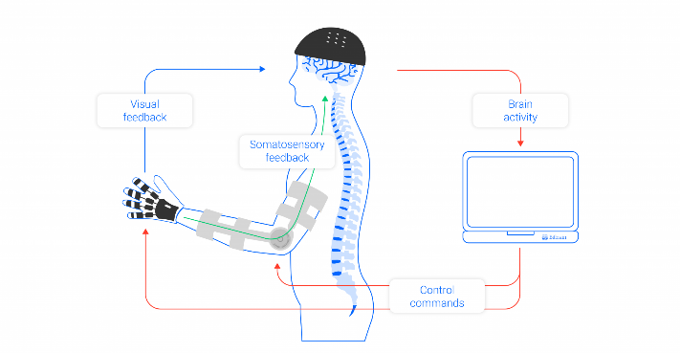In addition to its diagnostic potential, EEG has tremendous research value. Indeed, the technology has been used to explore brain function for nearly a century, and has been applied across diverse corners of psychology and neuroscience. Cognitive psychologists, for instance, frequently use EEG to investigate neural correlates of basic cognitive functions, such as emotion, language, attention, and learning. Likewise, some social psychologists use EEG results to augment analysis of group behaviour and social cognition.

1. For Consumers.

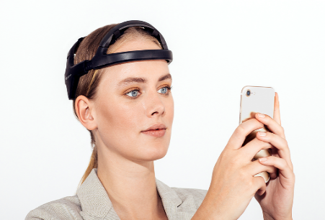Historically, brain scanning techniques have been large and expensive, thus limiting use to the confines of a research lab. By contrast, the latest EEG devices are portable and relatively inexpensive—features that allow scientists to use the technology in more natural and diverse environments. These traits also facilitate the use of electroencephalography beyond academic settings, such as for market research or educational applications.

The past decade has seen major growth in the consumer neurotech industry. There now exists dozens of brain wearables, with applications ranging from neurofeedback to hands-free gaming. Products in this category vary dramatically with respect to reliability and cost. As such, prospective customers should apply a healthy dose of scepticism to any seemingly-outlandish marketing claims.

|  |  |  |
| --- | --- | --- |
| **Tool Name** | **Developers** | **Description** |
| Anaconda | Anaconda Inc. | A distribution of the Python programming language for scientific computing. |
| Jupyter |  | A notebook format for sharing code and computational narratives. |
| Matplotlib |  | A 2D graphics package for the creation of publication-quality images. |
| NumPy |  | A library for scientific computing and analysis. |
| Pandas |  | A data library optimized for manipulating large and time series data. |
| PsychoPy |  | An application and library used to run psychology and neuroscience experi-ments. |
| MNE-Python |  | A library for preparing, analyzing and visualizing MEG, EEG and other related data. |
| scikit-learn |  | A machine learning library. |

**Chapter 2. Literature Survey**

* IEEE Xplore, 24 June 2010 🡺 Using Python for Signal Processing and Visualization

The Python programming language provides a development environment suitable to both computational and visualization tasks. One of Python's key advantages is that it lets developers use packages that extend the language to provide advanced capabilities, such as array and matrix manipulation, image processing, digital signal processing, and visualization. Several popular data exploration and visualization tools have been built in Python, including Visit (www.llnl. gov/visit), Paraview (www.paraview. org), climate data analysis tools (CDAT; www2-pcmdi.llnl.gov/cdat), and VisTrails (www.vistrails .org). In our work, we use VisTrails; however, nearly any Python-enabled application can produce similar results. The neuroscience field often uses bothmultimodal data and computationally complex algorithms to analyze data collected from study participants. Here, we investigate a study in which magnetic resonance imaging (MRI) is combined with electroencephalography (EEG) data to examine working memory.

* IEEE Xplore, 28 January 2016 🡺 Enhanced three-dimensional visualization of EEG signals

The analysis of EEG signals is a topic of significant interest to multiple scientific and medical branches. Since these signals lack any intrinsic visual data, their graphical representation presents multiple challenges, particularly for data spanning over frequency bands and extended durations. This paper presents several techniques for the representation of such signals, using a 3D model of a human head and multiple information visualization techniques, such as color scales, spots and glyphs. The proposed representation technique conveys an intuitive, efficient means to visually inspect EEG signals, while allowing the visualization of multiple relevant parameters without visually overloading the resulting images. Comprehensive descriptions of the aforementioned techniques are provided, as well as images containing the resulting representations. This approach intends to provide easy visual access to EEG data, for use in Brain-Computer Interface, medical or educational applications.

* IEEE Xplore, 04 November 2013 🡺 Classification and visualization for EEG data

We utilize a recent form of the Nested Cavities (abbr. NC) classifier from which a powerful new classification approach emerged. In this application there are many outliers in the datasets which we decided to judiciously remove. Further, working on the classification of Stage 3 we found wide dispersal in the data. After considerable experimentation we came to the conclusions that, at least between Stage2 and Stage3 some of the data has have been misclassified. By including some of the Stage2 data with values very close to those of Stage3 data and forming a New-Stage 3 ALL nine of the measured variables have tight value ranges and the whole data set visually appears as a well-defined cluster. In turn, accurate classification rules are obtained which had not been possible for the original partition into stages. These findings are explained, motivated and analyzed in this paper. Our thesis then is that some of the data has been misclassified in the original stage partition. This data is identified and new Stage 3 sets are formed whose classification reveals narrow range values of the measured waves providing a much clearer understanding of the sleep mechanism dynamics.

* IEEE Xplore, 09 February 2017 🡺 Enhanced visualizations for improved real-time EEG monitoring

An electroencephalogram, or EEG, is used to monitor the electrical activity in the brain through electrodes placed on the scalp. An EEG is a multi-channel time-varying signal describing voltages in different regions on the scalp, measured using electrodes. EEG recordings are interpreted using a montage, which defines the channels as differences between these electrodes. AutoEEG is a system that automatically interprets clinical EEGs and includes a variety of analytics that can be used to detect the onset of life-altering events such as seizures.

|  |  |  |  |  |
| --- | --- | --- | --- | --- |
| Sr. No. | Paper Title | Authors | Year of publication | Outcome |
| 1. | Using Python for Signal Processing and Visualization | Erik W. Anderson, Gilbert A. Preston, and Claudio T. Silva | 2010 | This paper proposes why and how python is best for signal processing and visualisation. |
| 2. | Enhanced three-dimensional visualization of EEG signals | Satya Prakash Singh,  Meenu | 2016 | This paper proposes how we can enhance our traditional 2D graphs and diagrams to modern 3-Dimensional Visualization of EEG signals. |
| 3. | Classification and visualization for EEG data | Pei Ling Lai1 Jin Liang Yang | 2013 | This paper proposes the methods and some algorithms to classify two datasets in varies ways. |
| 4. | Enhanced visualizations for improved real-time EEG monitoring | M. Thiess, E. Krome, M. Golmohammadi, I. Obeid and J. Picone | 2017 | Proposed Methodology of representation of EEG data, sensor position correlation. |

**Chapter 3. Proposed Detailed Methodology**

**3.1 Problem Definition**

Develop a project that will help one to analyse an EEG signal data. Develop a program or a way to visualize all this huge data in advanced and enhanced user-friendly view so, people can visualize EEG data in 3D. EEG analysis is widely used in brain-disease diagnosis and assessment. This project shall be helpful for that field also. Analysing EEG data and represent it in such way that user can interact with it and can see it however they want to see.

**3.2 Proposed methodology**

The targets of EEG analysis are to help researchers gain a better understanding of the brain; assist physicians in diagnosis and treatment choices; and to boost brain-computer interface (BCI) technology.

Non-invasive electroencephalogram (EEG)-based brain-computer interfaces (BCI) can be characterized by the technique used to measure brain activity and by the way that different brain signals are translated into commands that control an effector (e.g., controlling a computer cursor for word processing and accessing the internet).

An ever-increasing number of scientific studies are generating larger, more complex, and multimodal datasets. As a result, data analysis tasks are becoming more demanding. To help tackle these new challenges, more disciplines must now incorporate advanced visualization techniques into their standard data processing and analysis methods. While many systems let scientists explore, analyse, and visualize their data, such solutions are often domain specific, limiting their scope as general processing tools. One way to enhance their flexibility is to build them on top of an interpreted language.

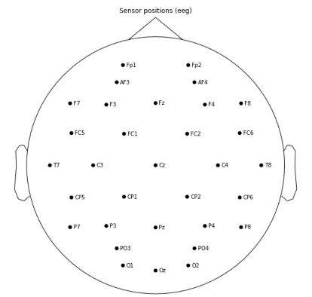**Sensers positions :**

**3.3 Resources Required**

|  |  |  |  |  |
| --- | --- | --- | --- | --- |
| Sr. no. | Resources Required | Resources name | Specification | Quantity |
| 1. | Softwares Resources | Python | Latest Version | 1 |
| 2. | MNE | Latest Version | 1 |
| 3. | Jupyter Notebook | Latest Version | 1 |
| 4. | Visual studio code | Latest Version | 1 |
| 5. | Browser | Latest Version | 1 |
| 6. | Hardware resources | Desktop computer/  Laptop | Ram min 4 GB | 1 |

**3.4 System Architecture**

**EEG data Processing**

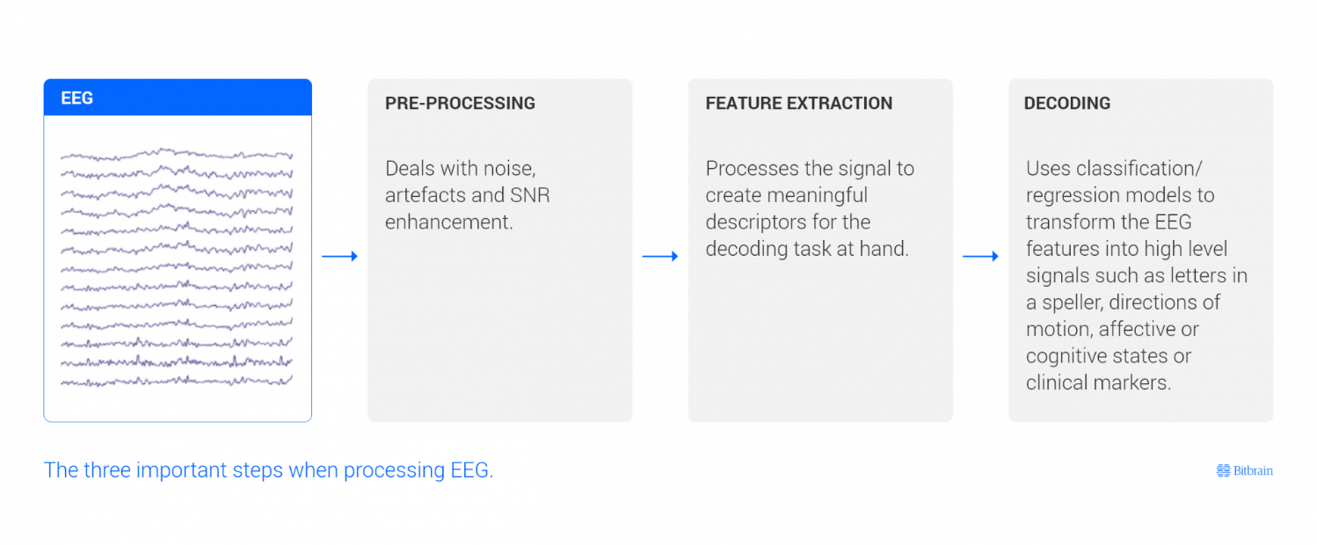

**MNE EEG workflow diagram**

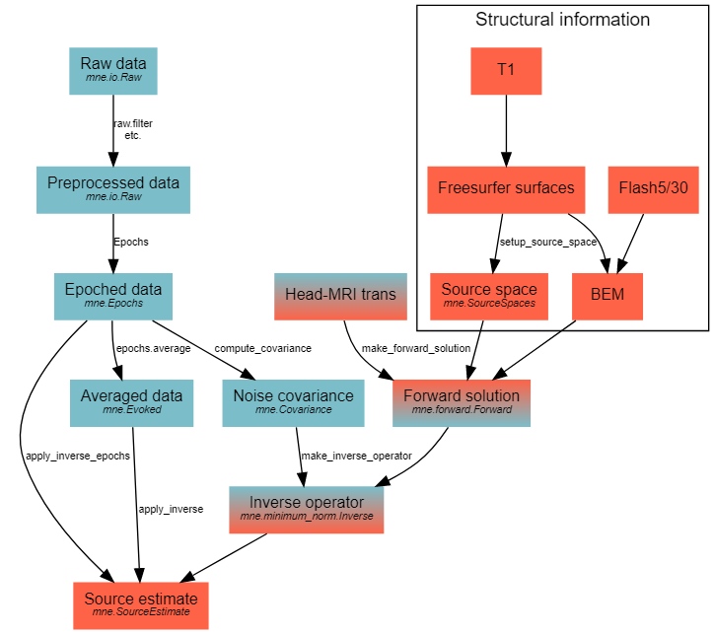

**3.5 Action Plan**

|  |  |  |  |  |  |  |  |  |  |  |  |  |
| --- | --- | --- | --- | --- | --- | --- | --- | --- | --- | --- | --- | --- |
| **Phases** | **1** | **2** | **3** | **4** | **5** | **6** | **7** | **8** | **9** | **10** | **11** | **12** |
| Requirement Gathering |  |  |  |  |  |  |  |  |  |  |  |  |
| Specification |  |  |  |  |  |  |  |  |  |  |  |  |
| Literature survey |  |  |  |  |  |  |  |  |  |  |  |  |
| Design Analysis |  |  |  |  |  |  |  |  |  |  |  |  |
| Implementation/Coding |  |  |  |  |  |  |  |  |  |  |  |  |
| Testing |  |  |  |  |  |  |  |  |  |  |  |  |
| Deployment |  |  |  |  |  |  |  |  |  |  |  |  |
| Documentation |  |  |  |  |  |  |  |  |  |  |  |  |

1. MNE tools - [Overview of MEG/EEG analysis with MNE-Python — MNE 1.0.dev0 documentation](https://mne.tools/dev/auto_tutorials/intro/10_overview.html)
2. Kaggle - [EEG Data Analysis | Kaggle](https://www.kaggle.com/ruslankl/eeg-data-analysis)
3. Medium - [Processing EEG data with python. EEG data is time-variant data and… | by Vishal_Kumar | Medium](https://medium.com/@vishal.mi19/processing-eeg-data-with-python-8036fd7336ca)
4. Neuro - [Background (unibe.ch)](https://neuro.inf.unibe.ch/AlgorithmsNeuroscience/Tutorial_files/Introduction.html)
5. On Using Python to Run, Analyze, and Decode EEG Experiments (Colin Conrad, Om Agarwal, Carlos Calix Woc, Tazmin Chiles, Daniel Godfrey, Kavita Krueger, Valentina Marini, Alexander Sproul and Aaron Newman)